Spring boot security !

When adding spring boot dependency we get this page when consulting our rest api endpoints !

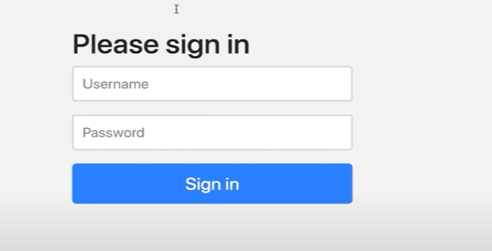

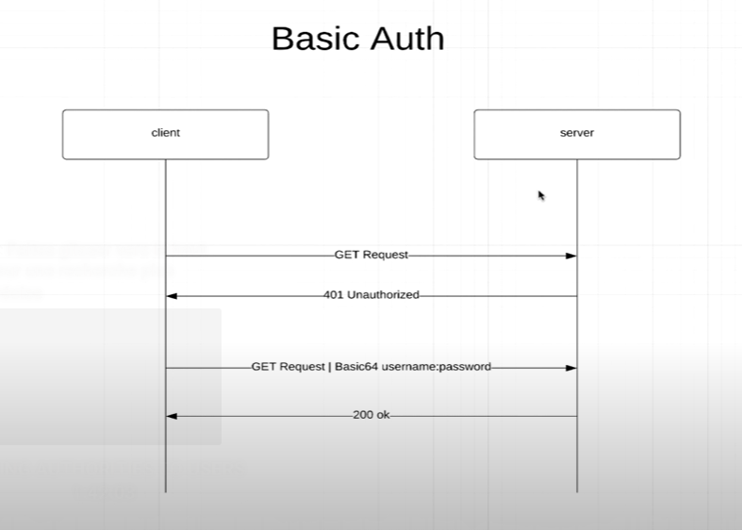

Inconvénient, le client doit envoyer le username et le password dans le header des GET request A CHAQUE FOIS qu’il veut communiquer avec un serveur.

We create a new package called ApplicationSecurityConfig, and annotate it with @configuration et @enablewebSecurity.

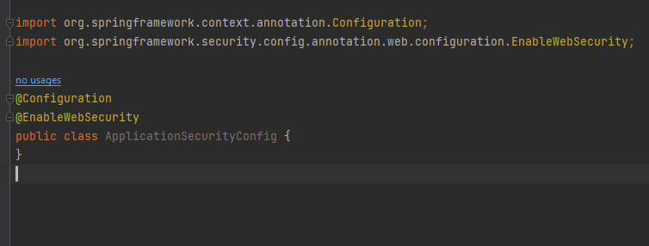

@enablewebSecurity tells spring that this is a security configuration class !

The first thing he will look for is security filterchain()

We will configure here everything that has to do with security !

The old way of doing stuff !

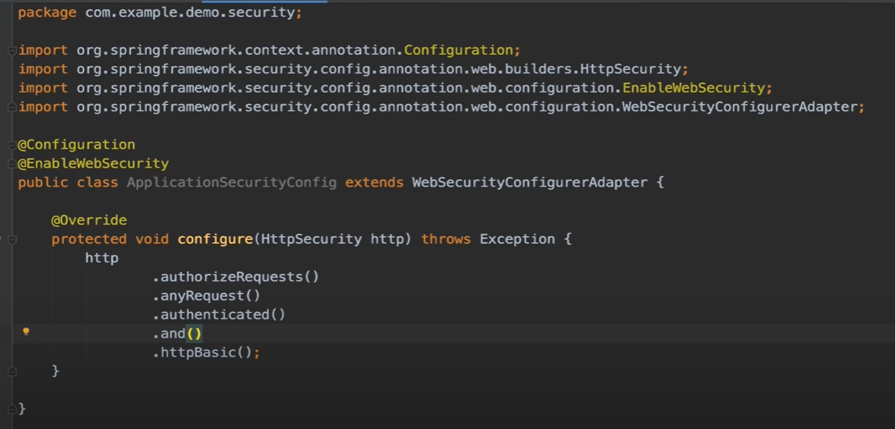

We take the http giving in the argument, and we authorizeRequests(), all request must be authenticated ie the client must specify and username and password using the mecanism Basic auth.

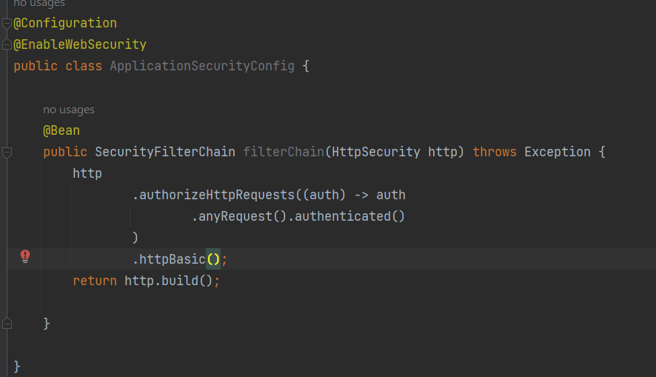

The new way of doing things require the usage of a SecurityFilter bean !

Now we git this when consulting the api endpoint !

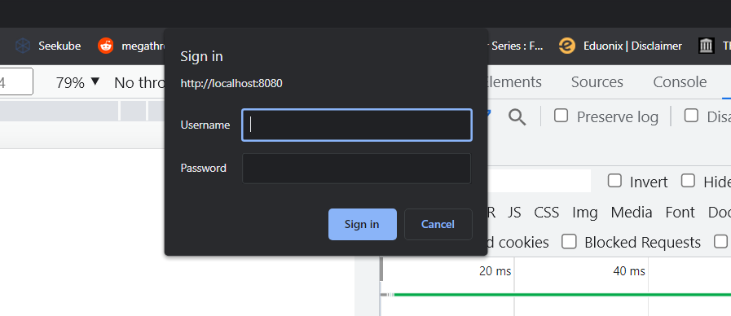

Using the basic auth, u can’t logout.

Si on veut qu’on page soit accessible par tous les utilisateurs sans avoir à se connecter on utilise ce qu’on appelle les ANT MATCHERS !

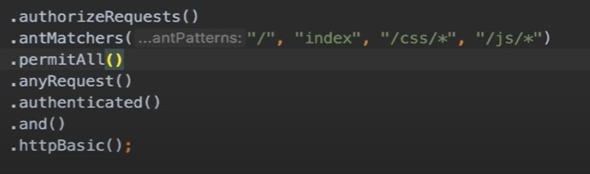

Dans antMatchers, on veut dire par ‘ /’ le root, ‘index’ tous fichiers qui contient index, et tous les fichiers css/js.

Le permitAll() permet ses patterns définis dans le antMatchers.

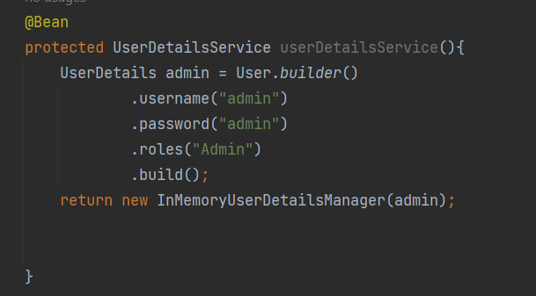

userdetailsService, is how u retrieve ur users from the database, for now i define one manually ! and call it admin, that has a username password admin and its role is Admin, then i build this user !

In order for this to work, we must add password ENCODER ! otherwise we get this error :



We create a new class, for the password encoder

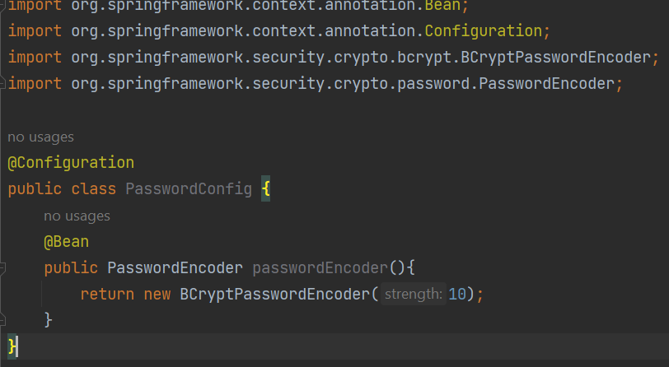we use passwordEncoder, an interface 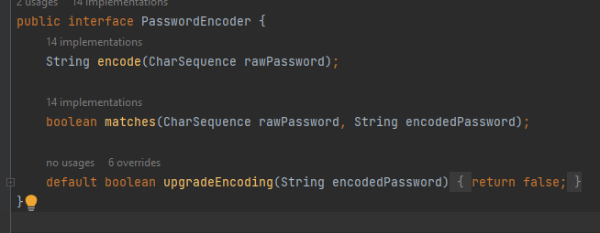

BCryptPasswordEncoder the most popular password encoder, then in Applicationsecurity, we use some dependency injeciton !

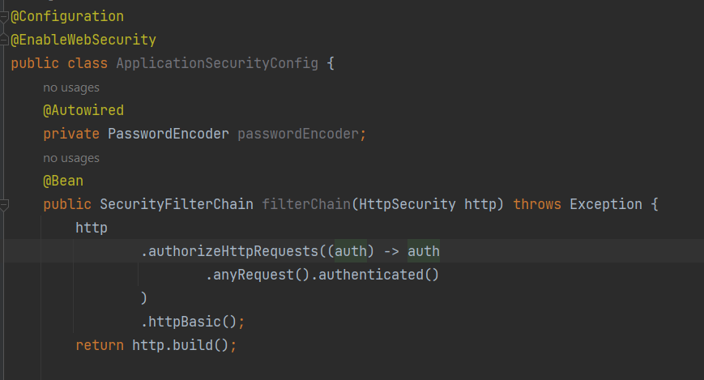

Instead of giving the raw password, we encode it !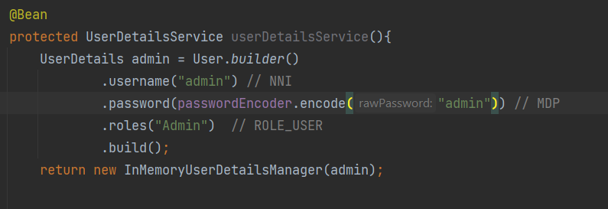

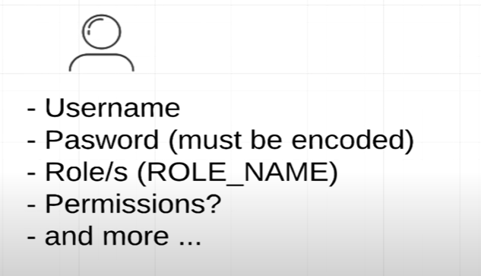

We create 2 enums, one for the roles (admin, utilisateur,..) and the other for the permission (admin :read+write, ..) 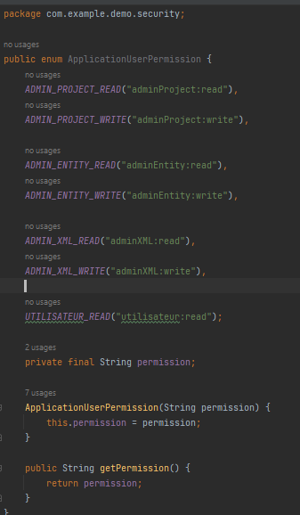

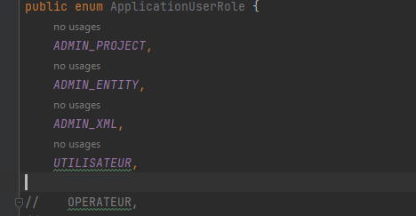

We add then a new dependency :

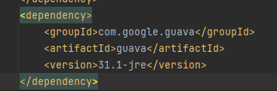

Every role can have 0 or multiple permissions !

In roles enum, we link roles with permissions !

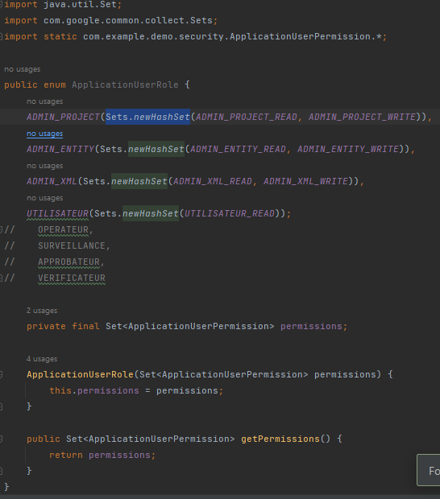

Exemple :

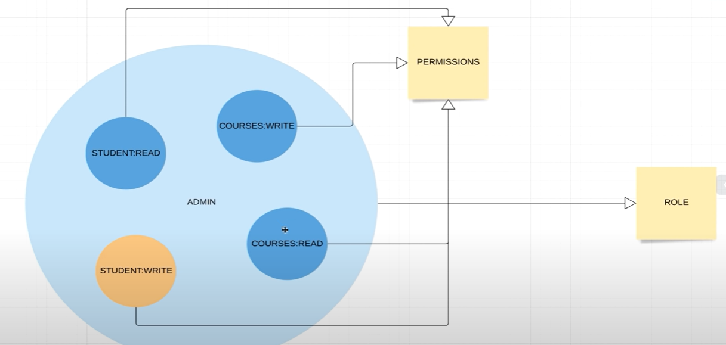

Role admin have multiple permissions, he can read student, write student, read/write courses !

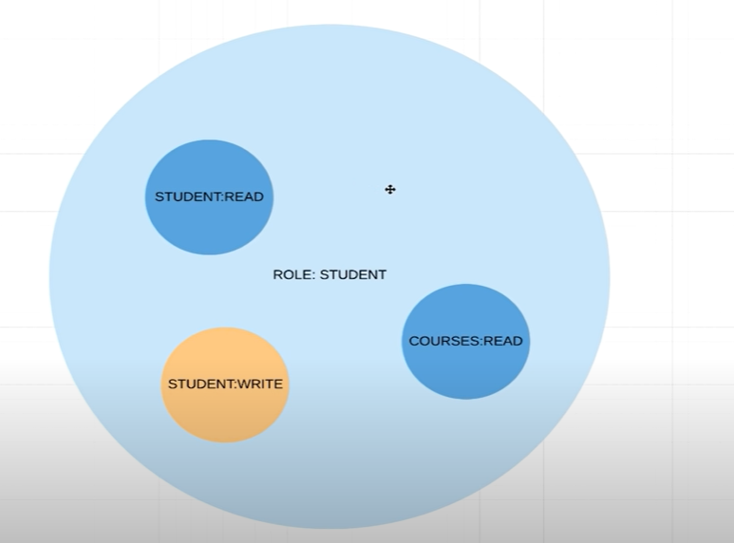

Student role can view/update his student info, and read courses, but can’t write courses ! 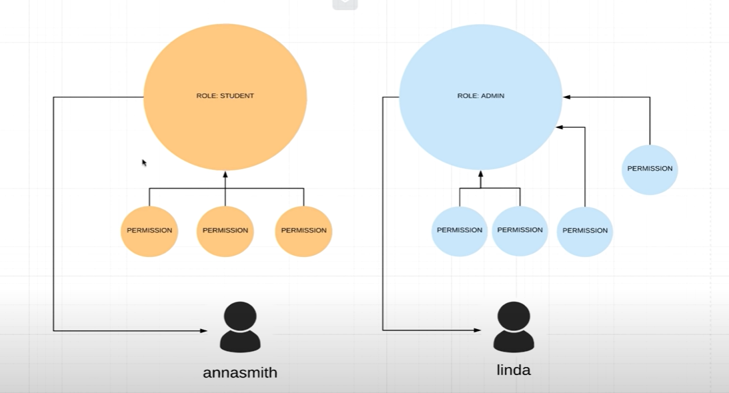

We can attach permissions to roles. You can assign more than one role to a user.

Our permission !

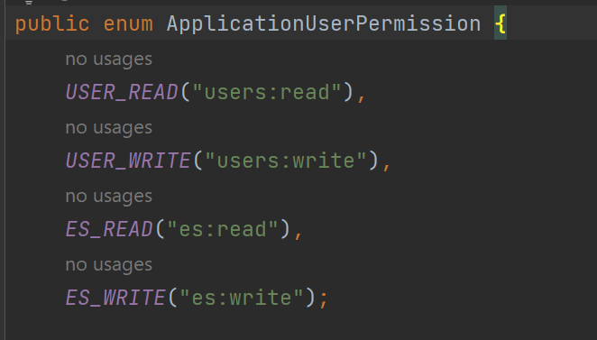

What we can do ? read or write users, read or write Es !

Then we attach our permissions to our roles !

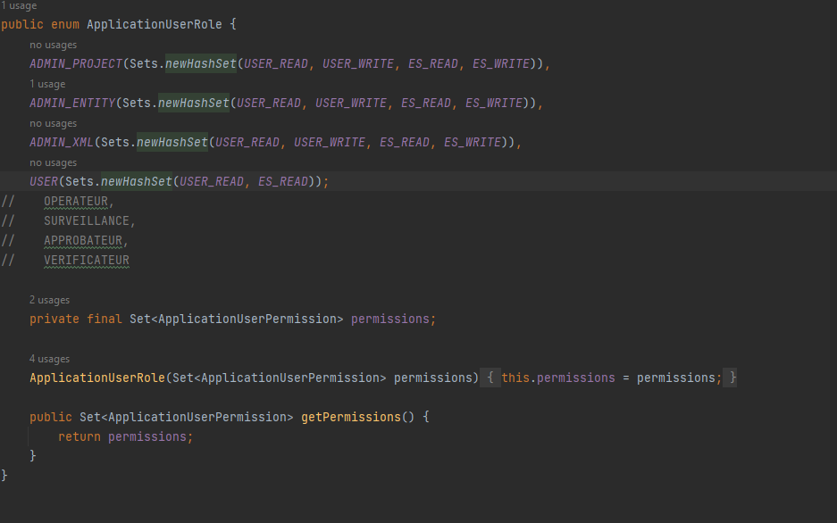

Protect API with role based authentication !

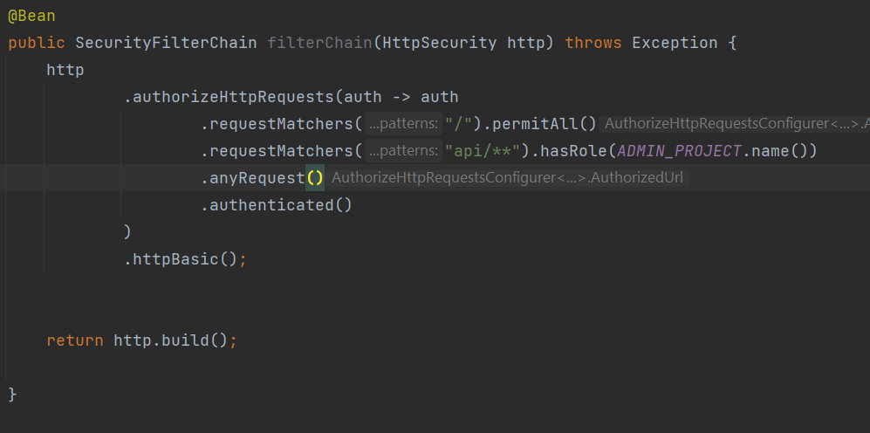

.requestMatchers allow us to secure ou api endpoints !

Api with the uri « / » root is permit to all,

Api with uri /api/ permitted only to admin_project, so we remove the right to acces this api to other roles !

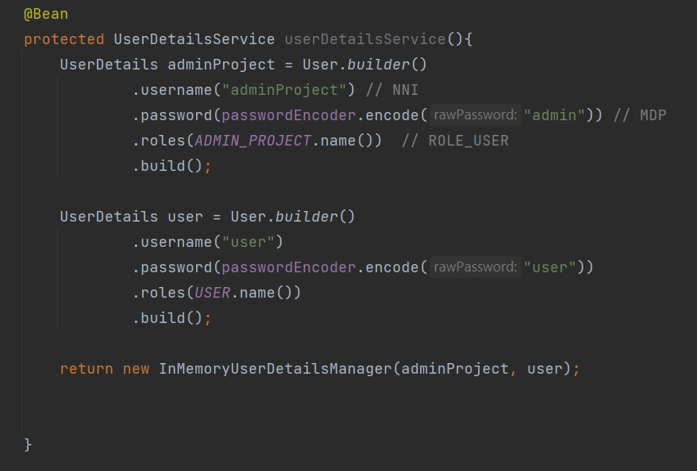

Protect API with permission based authentication !

We create more restful controllers 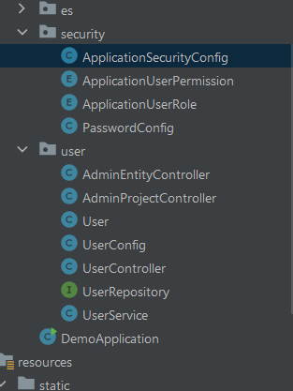

One for each type of user !

If we try to send post/delete/put request, it will fail !

We need to disable the csrf !

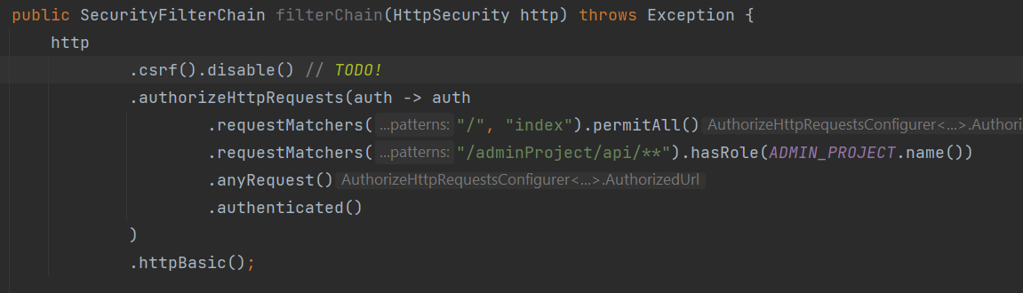

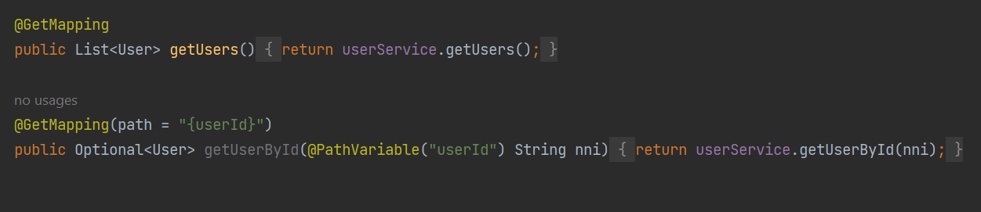

The user type USER can now only get the data,

Later on he will only get the data of the same entity type as him !

We move the post/request/delete request to the admin project controller !

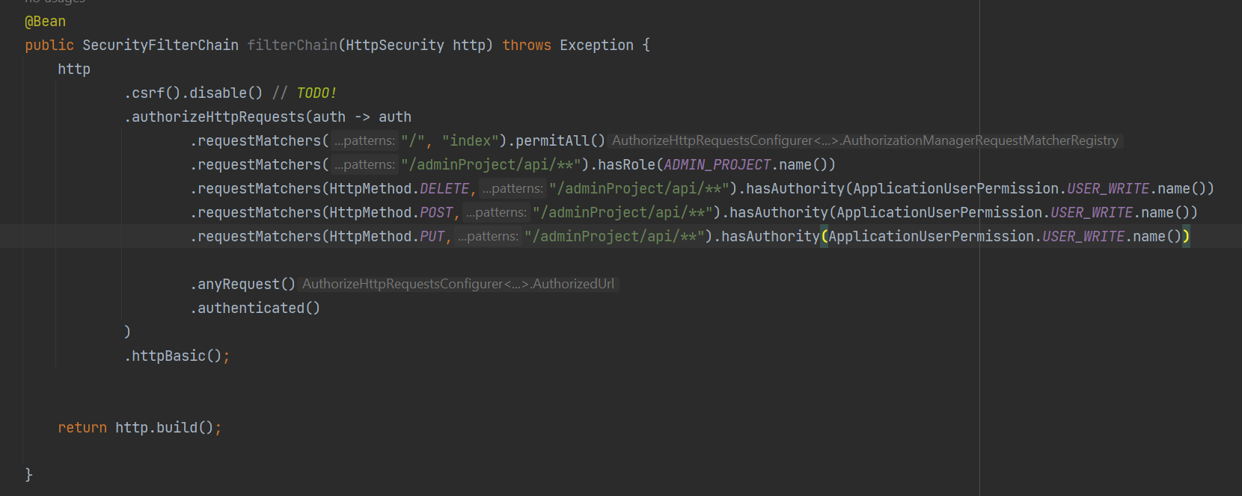



http METHOD delete, from the api uri, can only be executed if the user has the permission given.

ADDING AUTHORITIES TO USERS !

IN role enum we define !

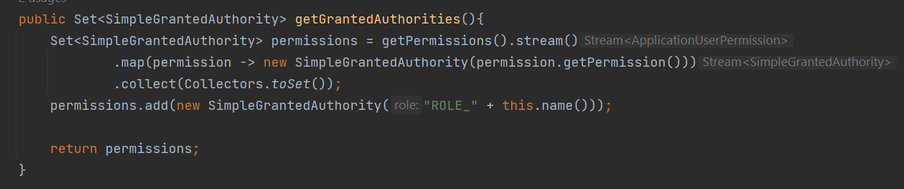

And we change role into authorities :

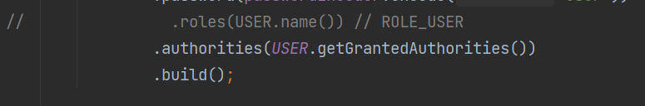

And we change .name to get permission !

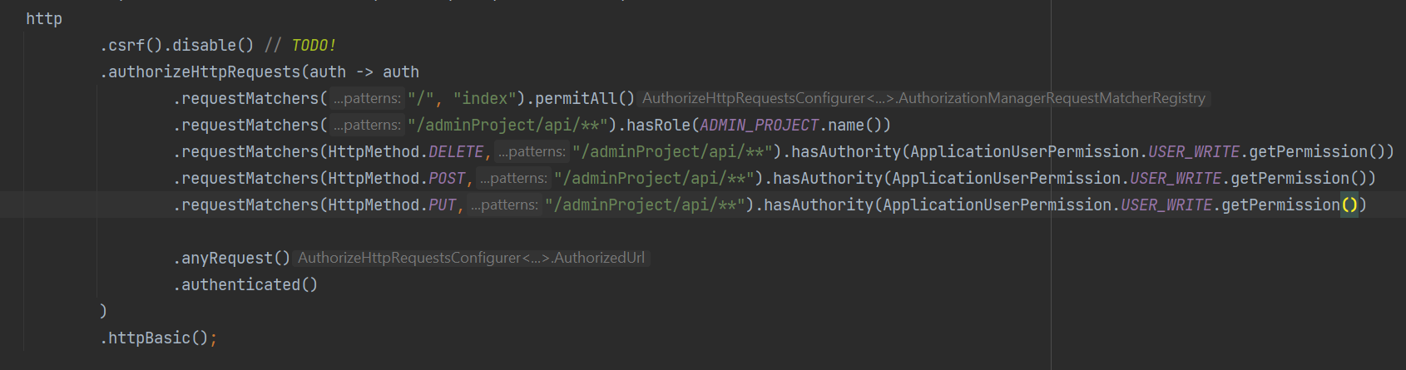

Somthing to note is that the order of the matchers is important ! it goes through the matchers one by one !

If u access the admin/project/api/* ? if yes, then do u have the authorities needed ? if no, it blocks immediately the access and so on.

We can secure specific methodes using annotations !

@PreAuthorize()

We control what roles or permissions can access the methods !



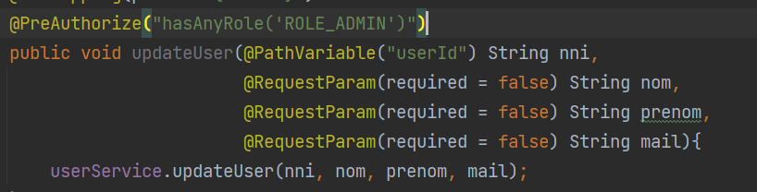

We replace all the antMatchers with these annotations !

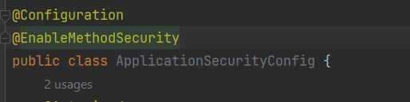

We add the @enbalemethodsecurity annotation to activate the preAuthorize annotation !

UNDERSTANDING CSRF !

Cross Site Request Forgery !

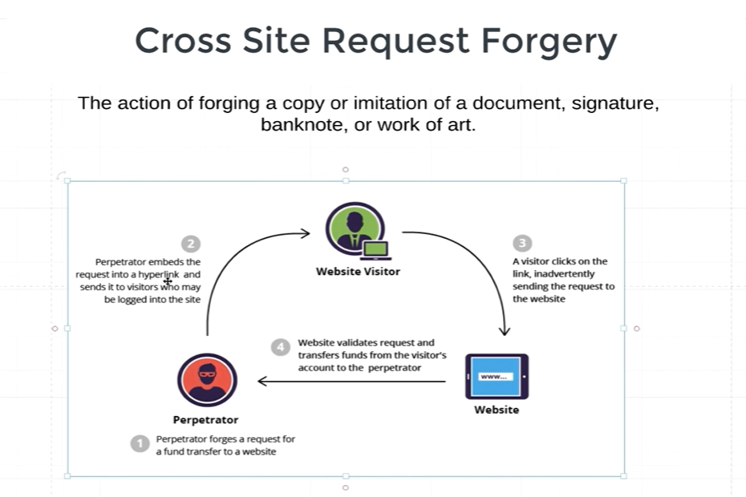

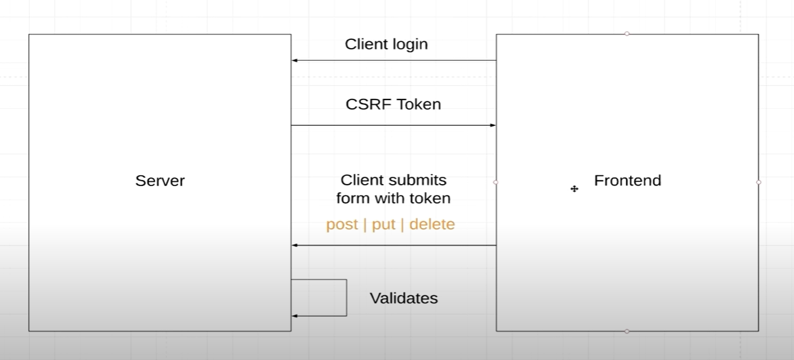

How to get the backend to send the request to the frontend !

BASIC AUTH :

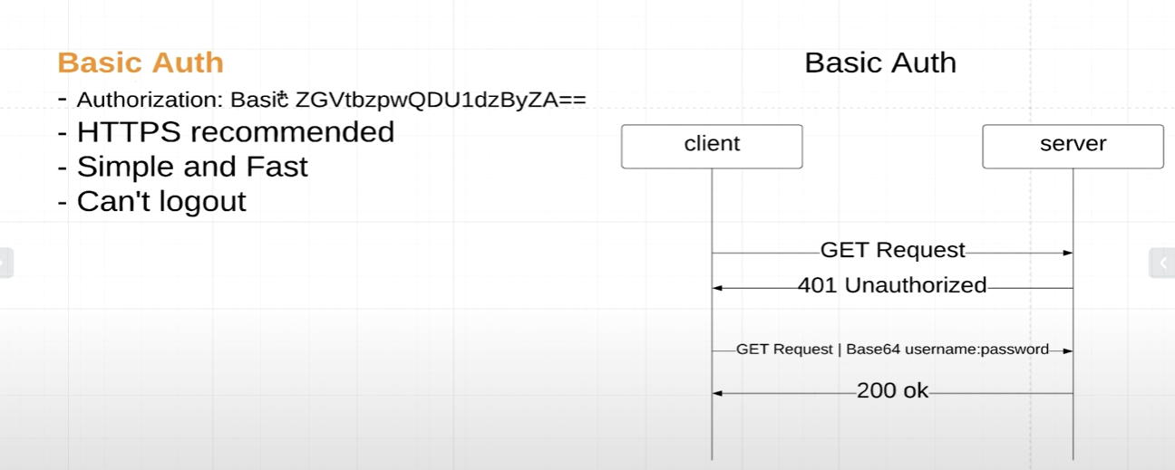

FORM BASED AUTH :

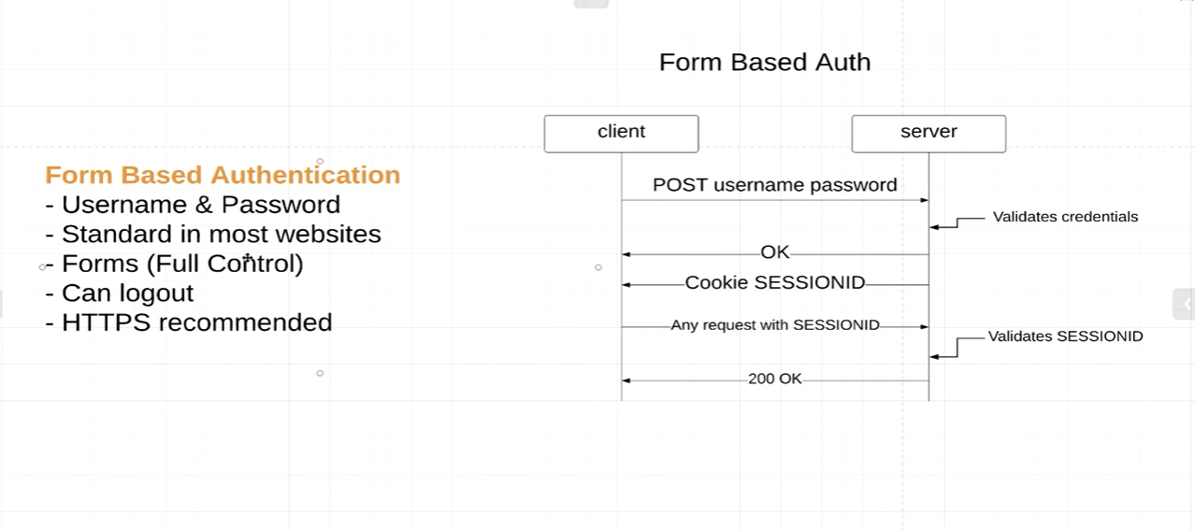

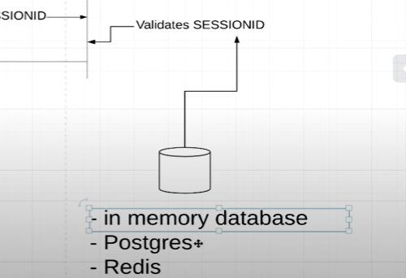

You can customize the login page !

To enable from based auth, we switch from httpBasic() to formLogin()

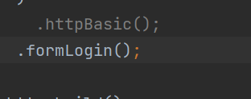

To customize the login page !

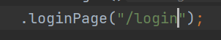

And we need to add a dependency !

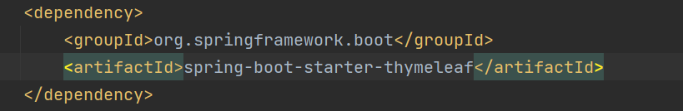

Thymeleaf is a templating engine for html

Fetching users from a database !!

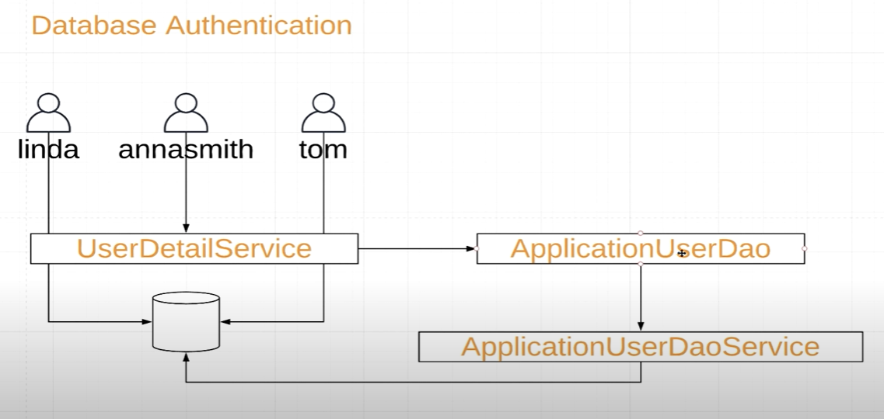

The userDetailService is a layer that get userdetails !

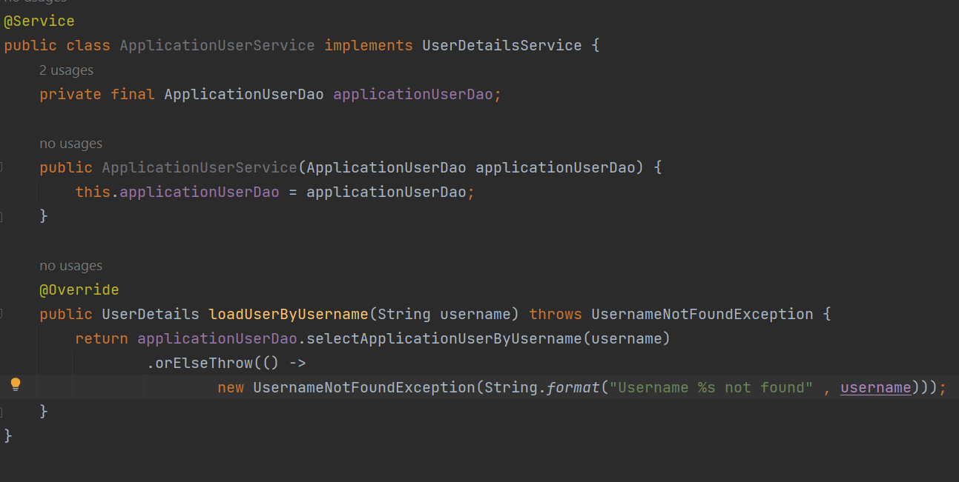

It’s the class ApplicationUserService that implements userdetailService.

The interface ApplicationUserDao !

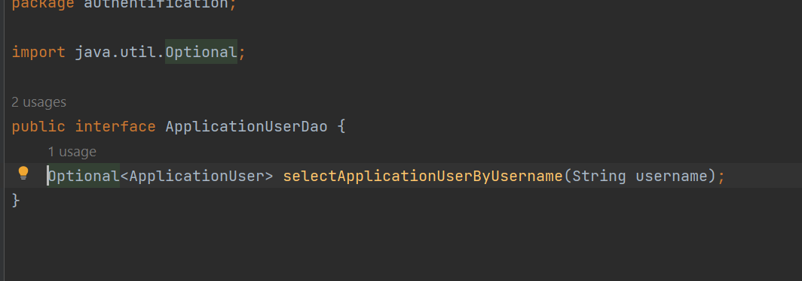

Where we have the query to fetch users by username.

We create a class called ApplicationUser that implements the userDetails, we will map our users to this class !

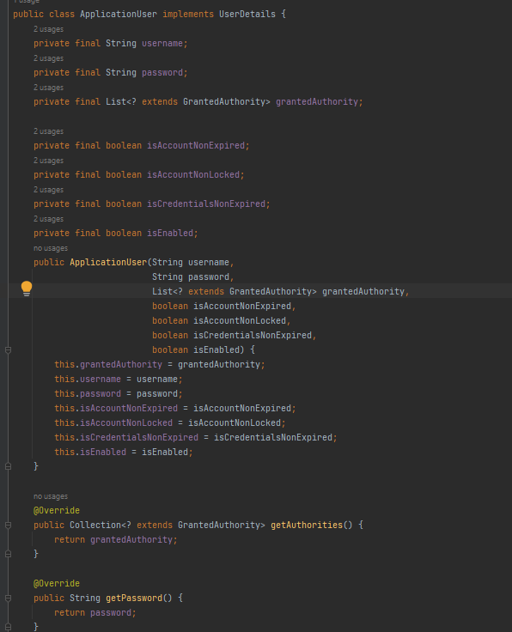.

We create now ApplicationUserDaoService ! it will be responsable for managing our users in the database !

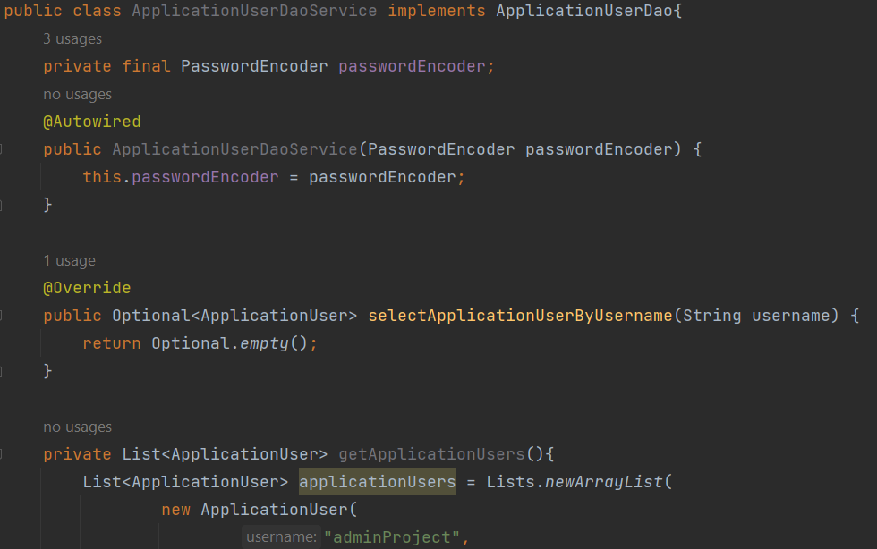

Inside we define a method that create users in memory database 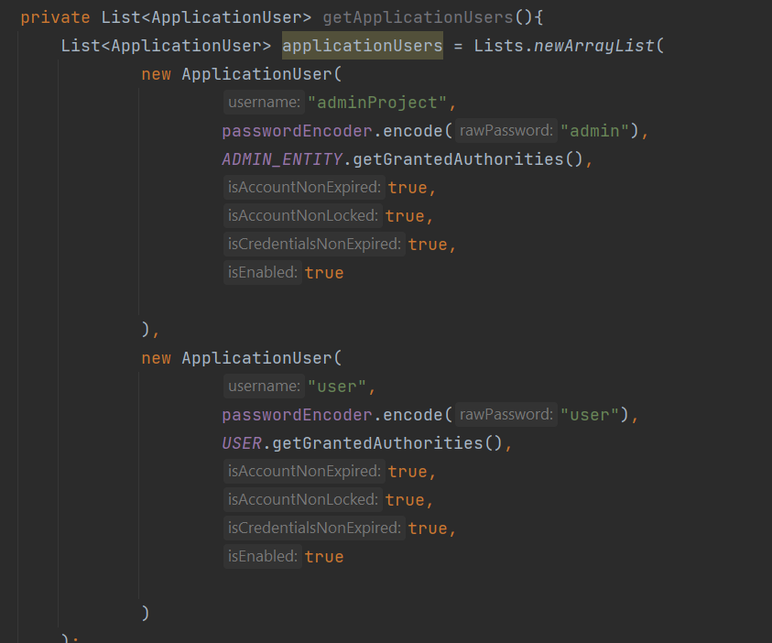

Return applicationUsers ;

Later on we should fetch this users for our database !

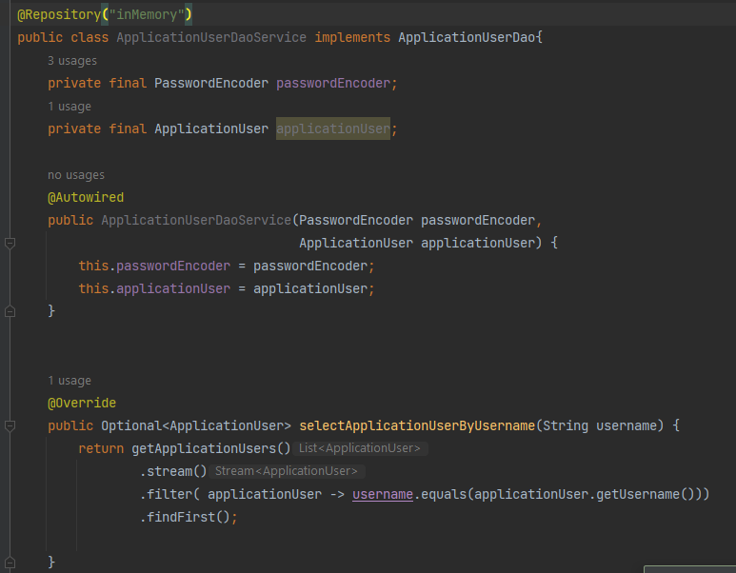

We overide the method that we created in the interface ApplicationUserDao.

@Repository tells spring that the class should be instantiated (dependecy injection), we give it a name, in case we have multiple implementations when we autowire.

When we autowired in applicationuserService

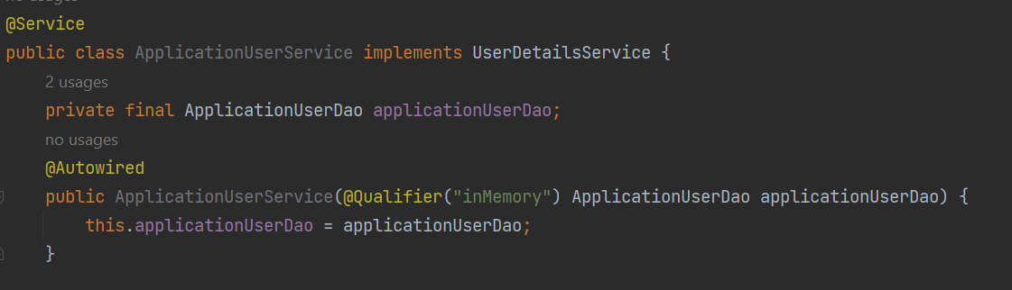

We use @Qualifier to specify the implementation in case we have a lot!

Then , we wire everthing ! we change applicationSecurityConfig.

We delete this method ! 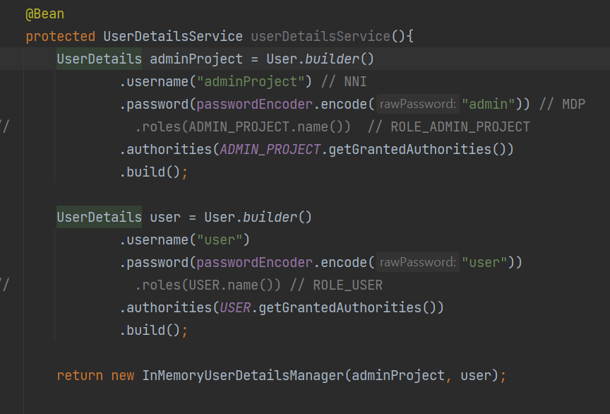

We create this method !

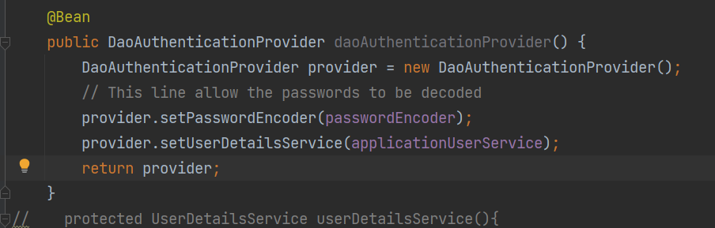

JSON WEB TOKEN / JWT :

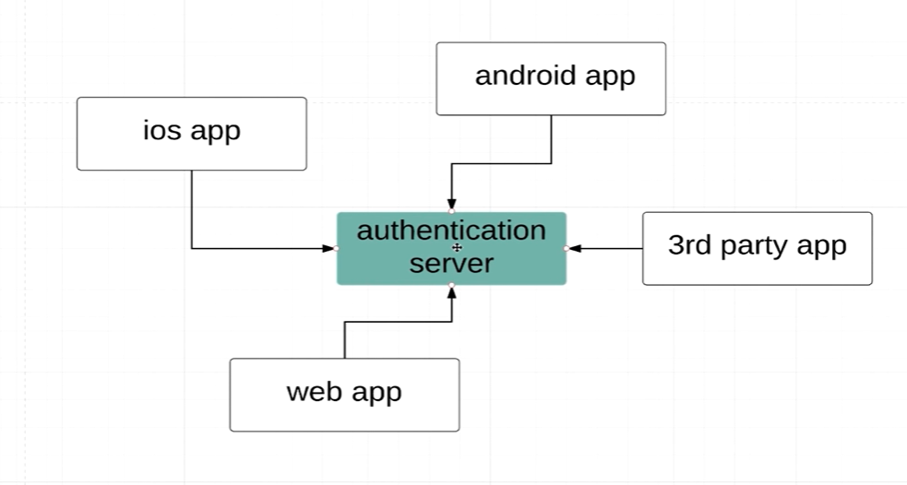

If every entity is using a different based of httpsecurity (basic auth, form basic)

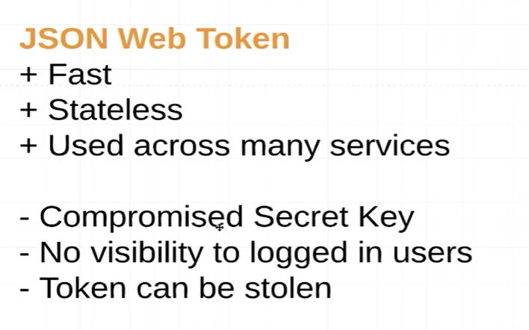

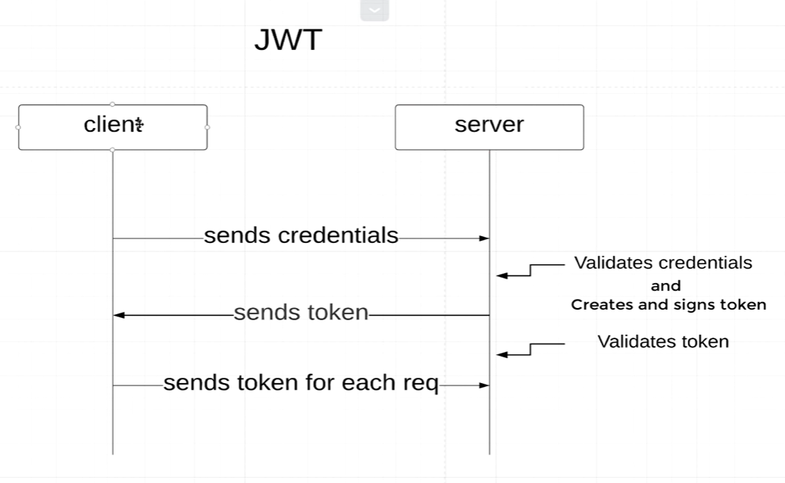



Takes the value that comes from the input stream, and map it on top of our class.

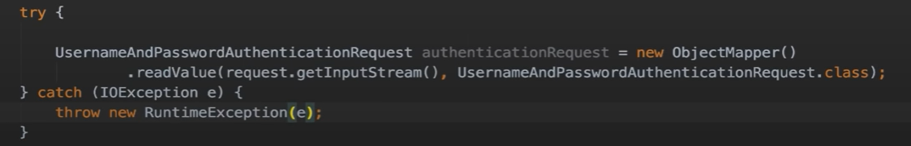

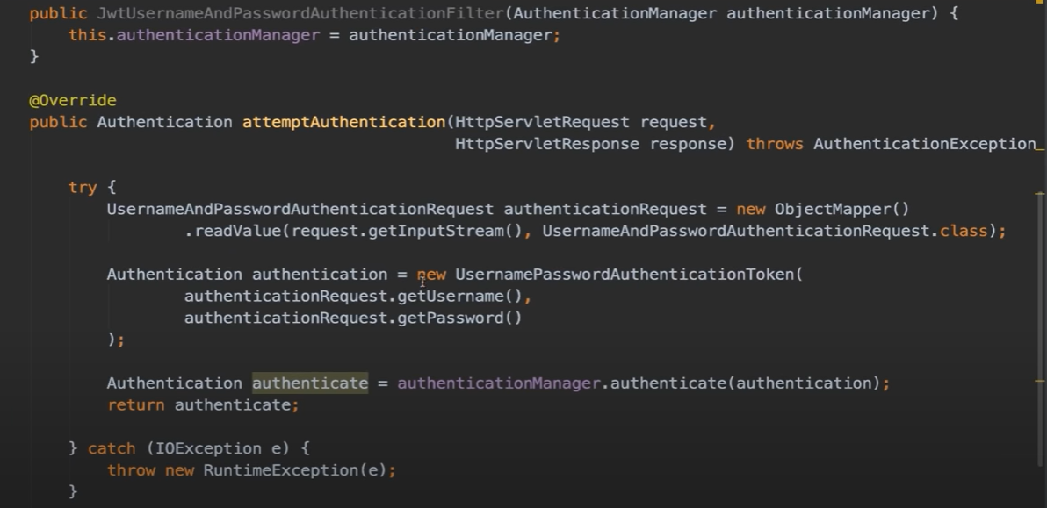

This code is for the send credentials + verify crendentials part !

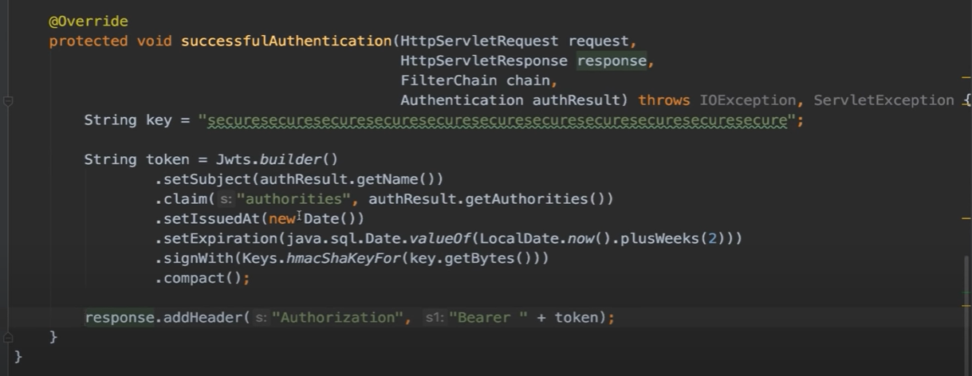

This part of code is responsable for generating the token and send it back to the user !

Request filters !

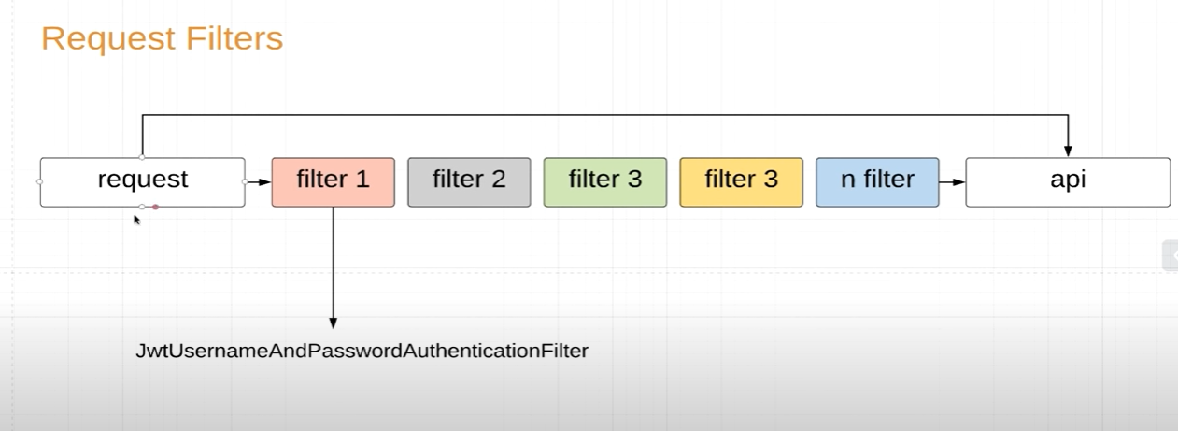

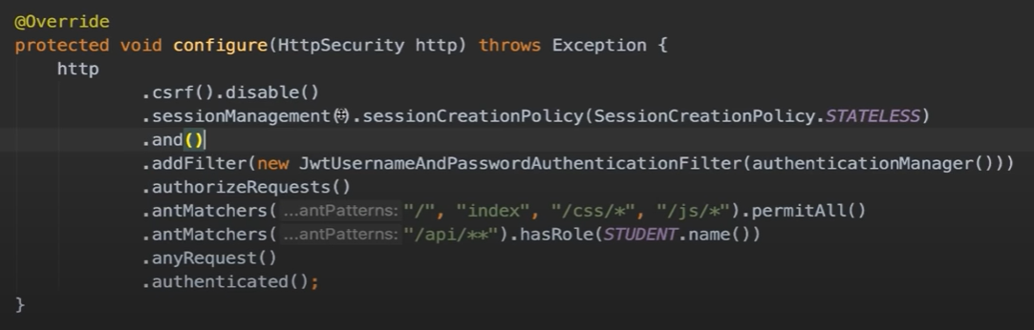

To apply filters ! filters are STATELESS !

JWT !

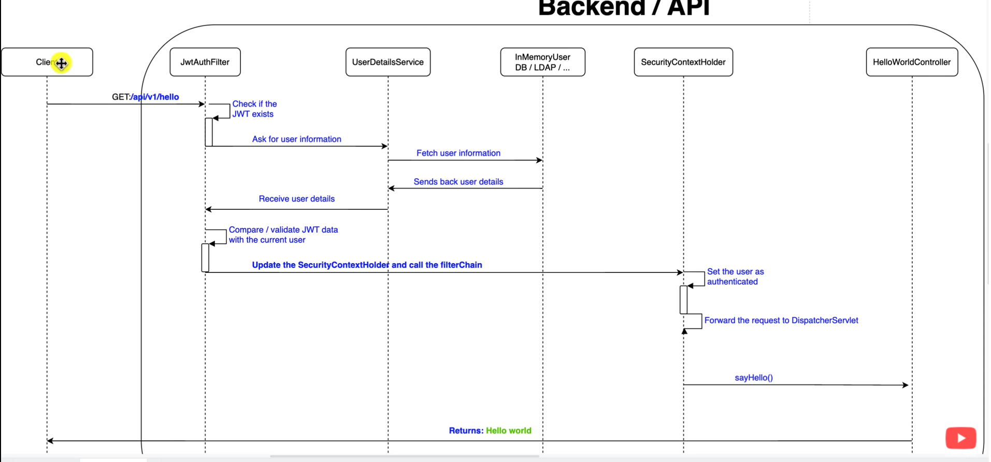

We need to add a dependency !

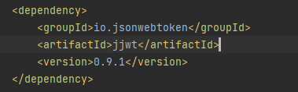

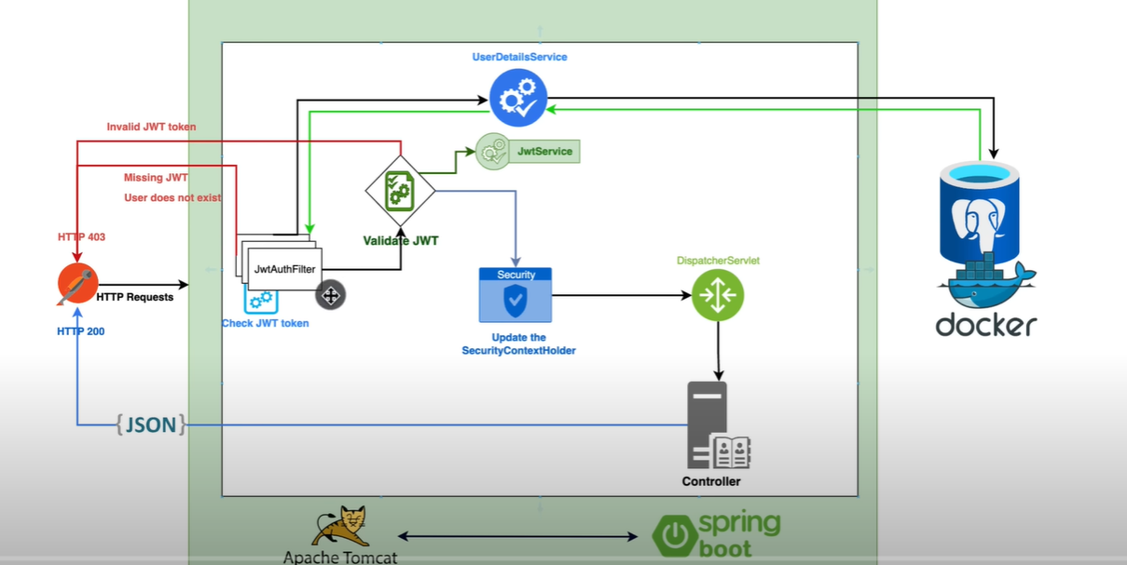

Instead of defining getters and setters and constructors we use lombok annotations :

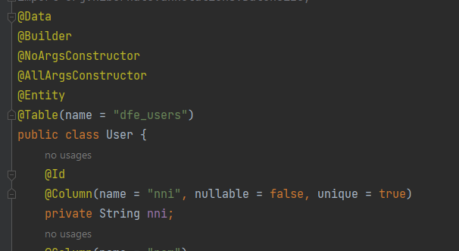

Our roles comes from profil ! so we change profil from string to our enum, applicationUserRole.

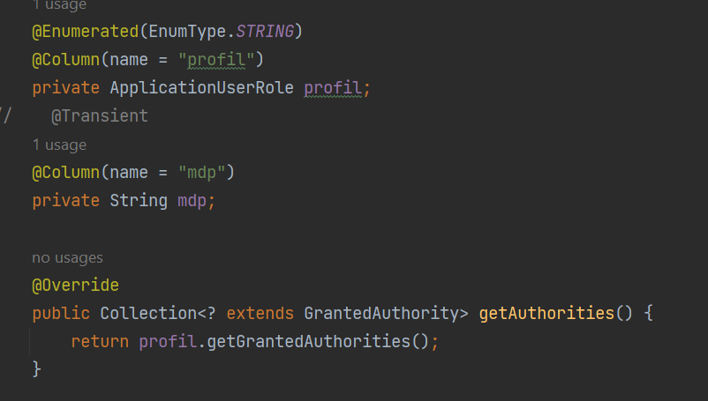

And for the getauthorities method we call getgrantedAuthorities !

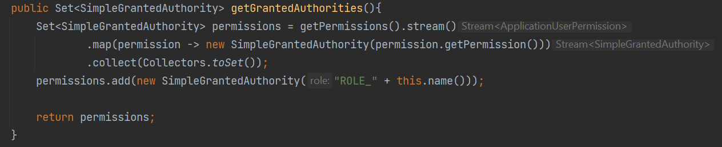



We create a package for filtering requests !

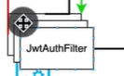

We want this filter to be active everytime a request is sent by the user !

So it extends a class !

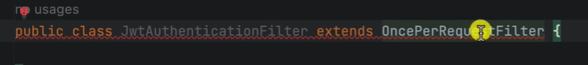

We must override this method !

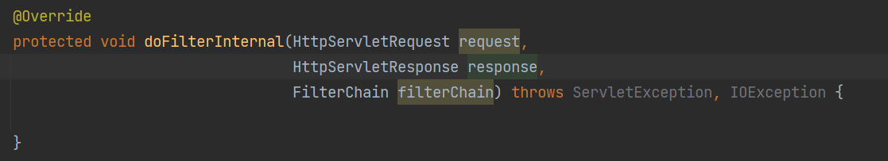

We can intercept the request and extract data from it and put it in response, or provide new data in the response !

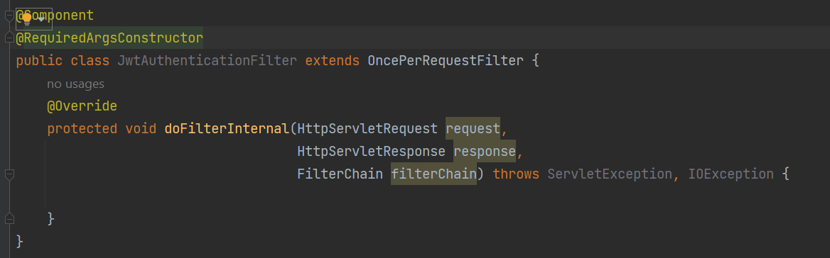

We add @Component so spring knows that this class is a spring bean !

@RequiredArgsConstructor is a lombok annotation that will create a constructor using any final field that we declare.

The first we do is checking the jwt token.

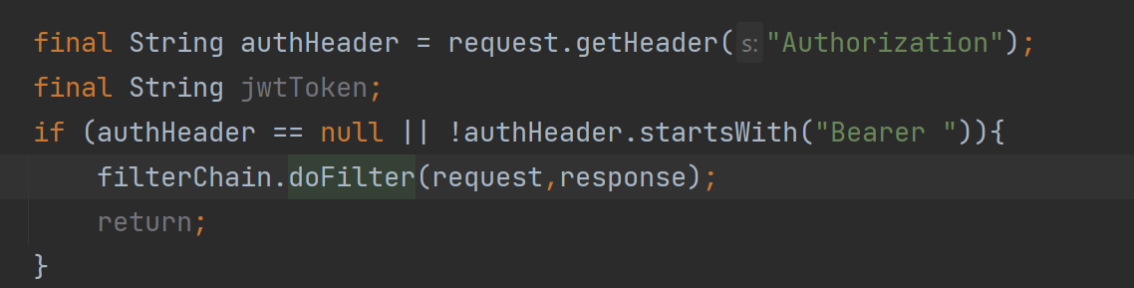

If my authheader is null or doenst start with bearer we pass the request and response to the next filter and we do an early return !

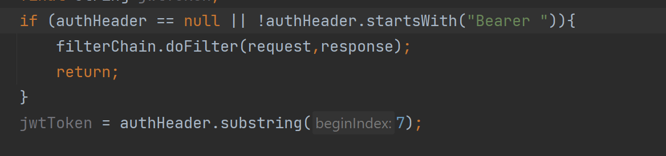

Next we extract the token, starting from 7 because Bearer .length = 7 ;

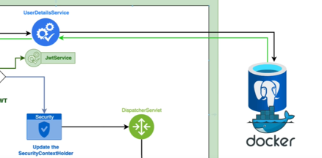

Next we have to check whether the username exists in our database, to do so first we need to extracte the username from our tokan 

We need a service class (layer) that can extracte username from a jwttokan !

In order to manipulate the jwtoken we need extra dependencies !

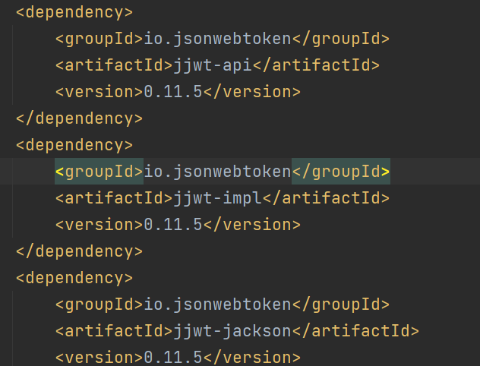

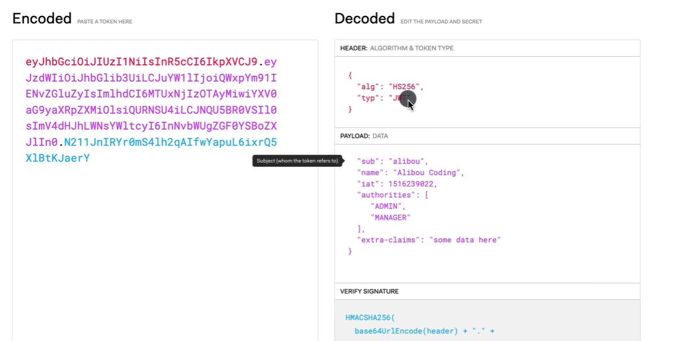

Within the jwtService, we define a method called 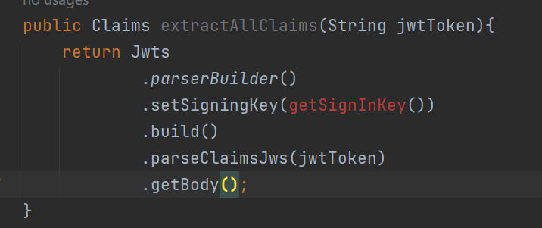

It allows us to extracte all claims from a jwt token .

We use Jwts that coms form jsonwebtoken,

.parserBuilder() to parse the token, .setSignInKey, we need the signing key in order to generate or decode the token, then we build our parser, and parse our token and from that we getBody.

We need the key in order to sign the jwt, it is used to create the signature part of the jwt, to verify the sender !

We can generate key online !

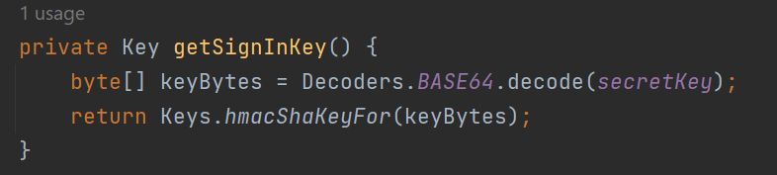

We decode the secretKey on base64.

We create then a method that allows us to extracte one claim !

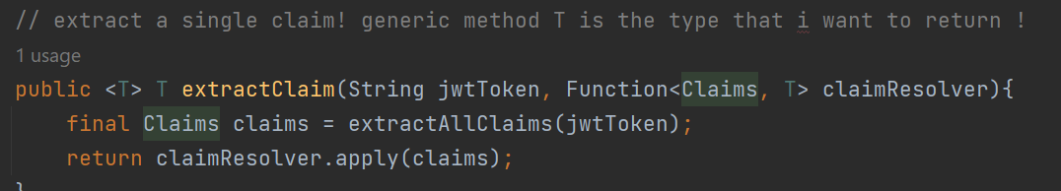

And finally we create a method that allows us to extracte the username !

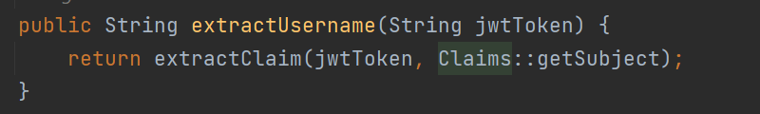

This method will generate the token

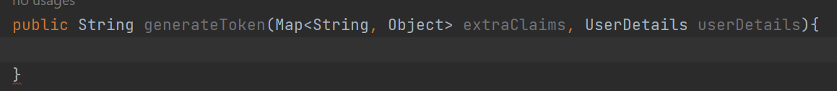

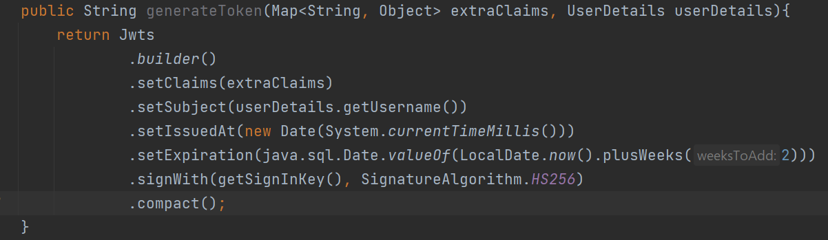

We can also generate a token directly from userDetails !

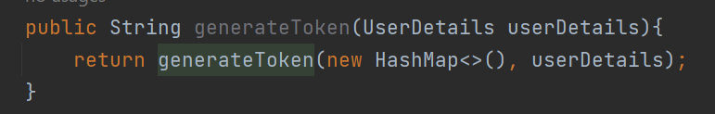

Next we will create a method that can verify if token is valid and not expired!

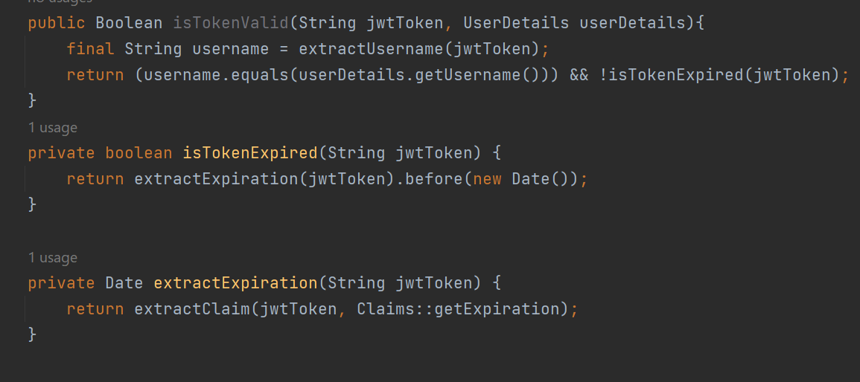

We go back to our jwt authenticationfilter



we check if the username is not null, and if the user is not already authenticated !



If so we load the information into a variable of type UserDetails ! 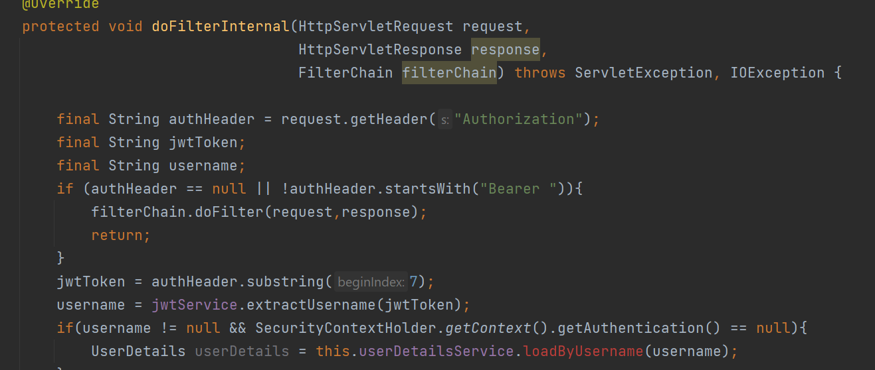

we create a class, and call it applicationConfig, it ‘s where we will config all our beans !

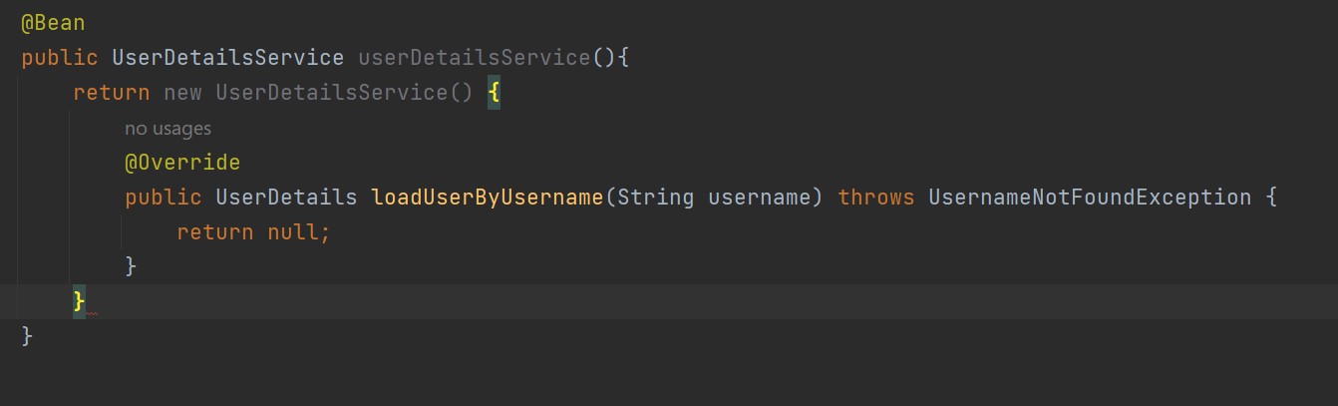

Or use lambda expression

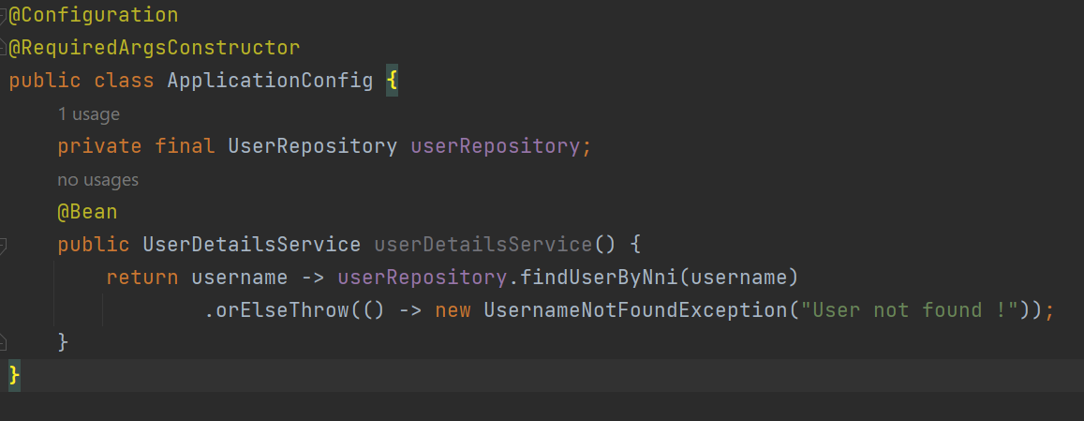

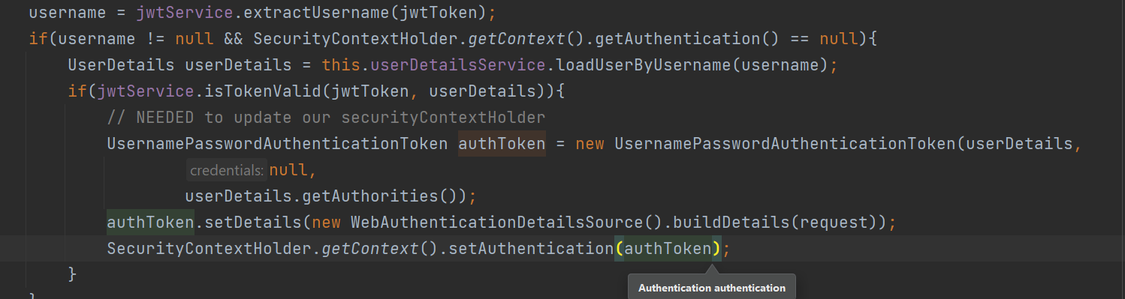

If is true, we get our userdetails from our database, and we check if the user/token is valid or not, then we create an object of type

UsernamePasswordAuthenticationToken

we setDetails of our request and update it to our security context holder.

To manually define users !

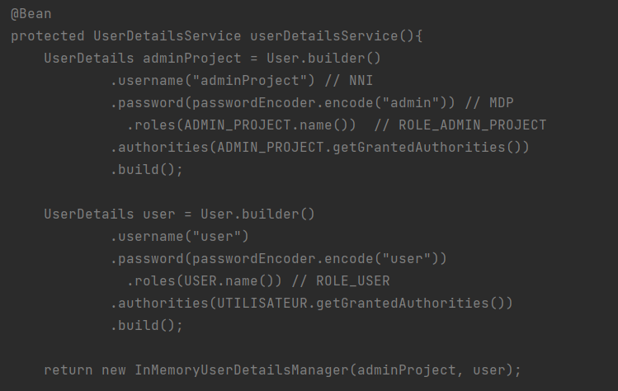

Package security !

The applicationSecurityConfig !

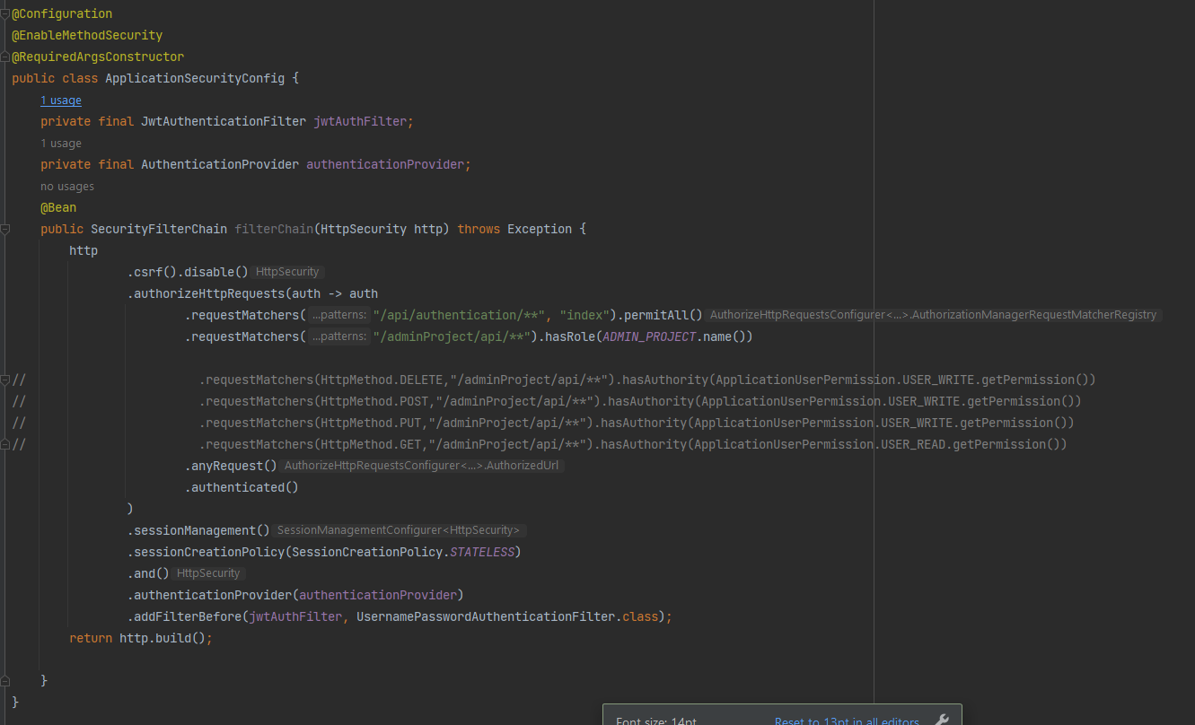

applicationUserRole 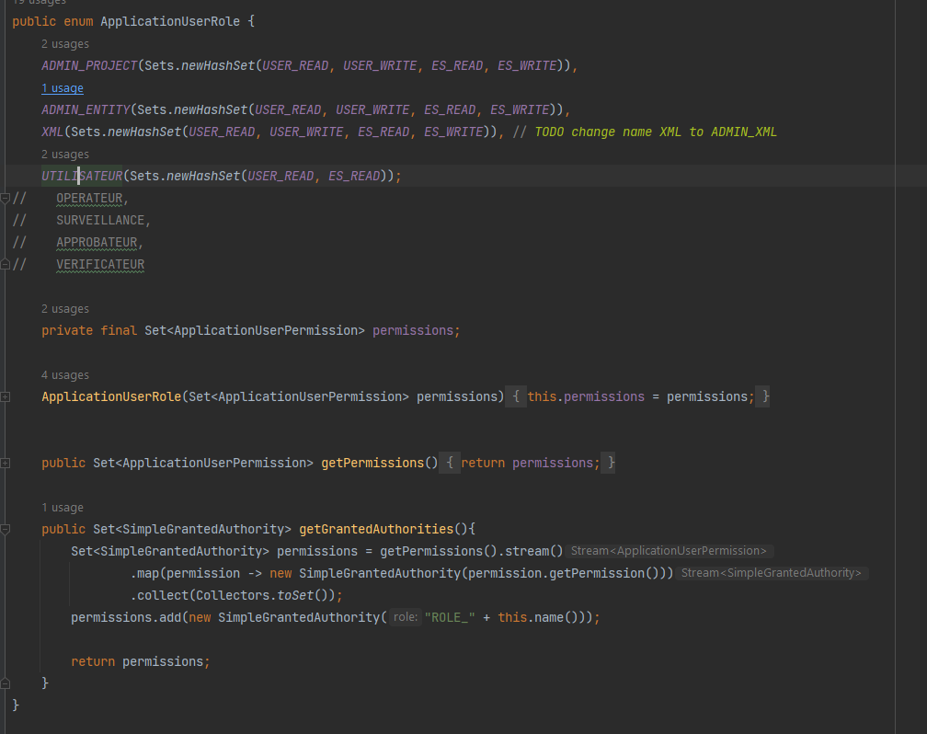

applicationUserPermission !

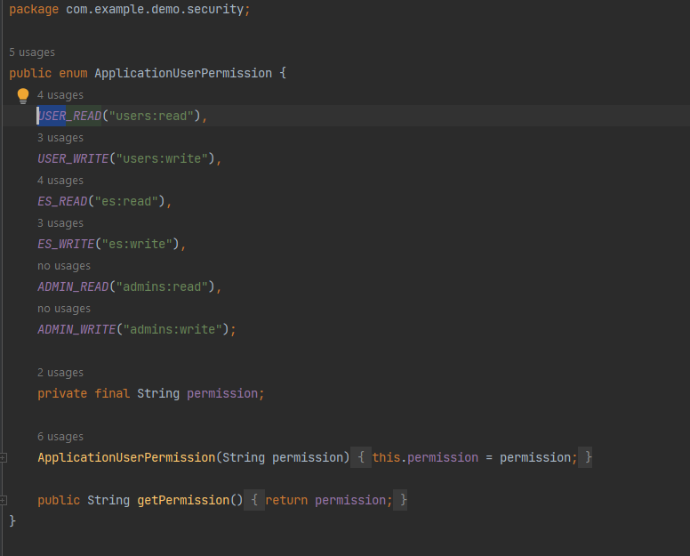

Package jwt :

JWTAuthenticationFilter.

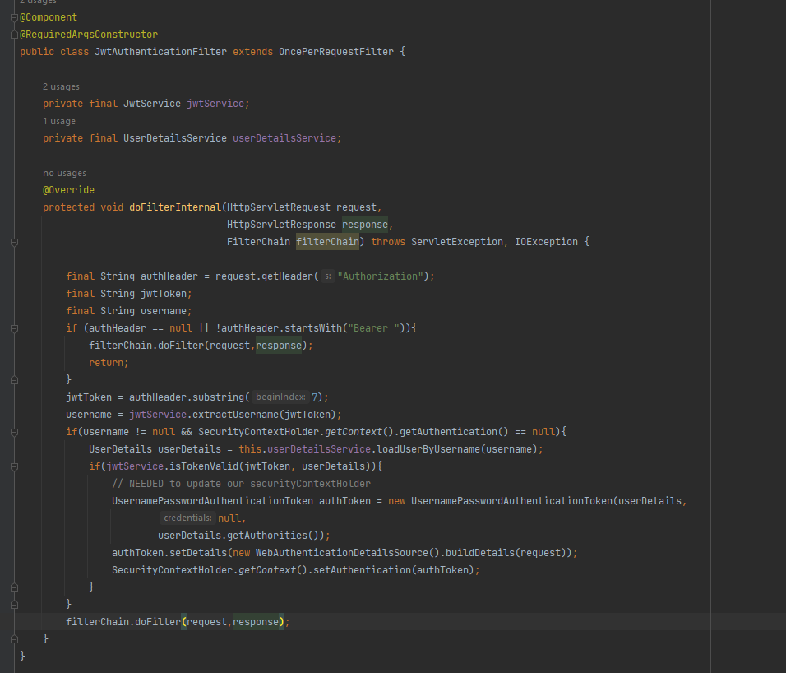

jwtService !

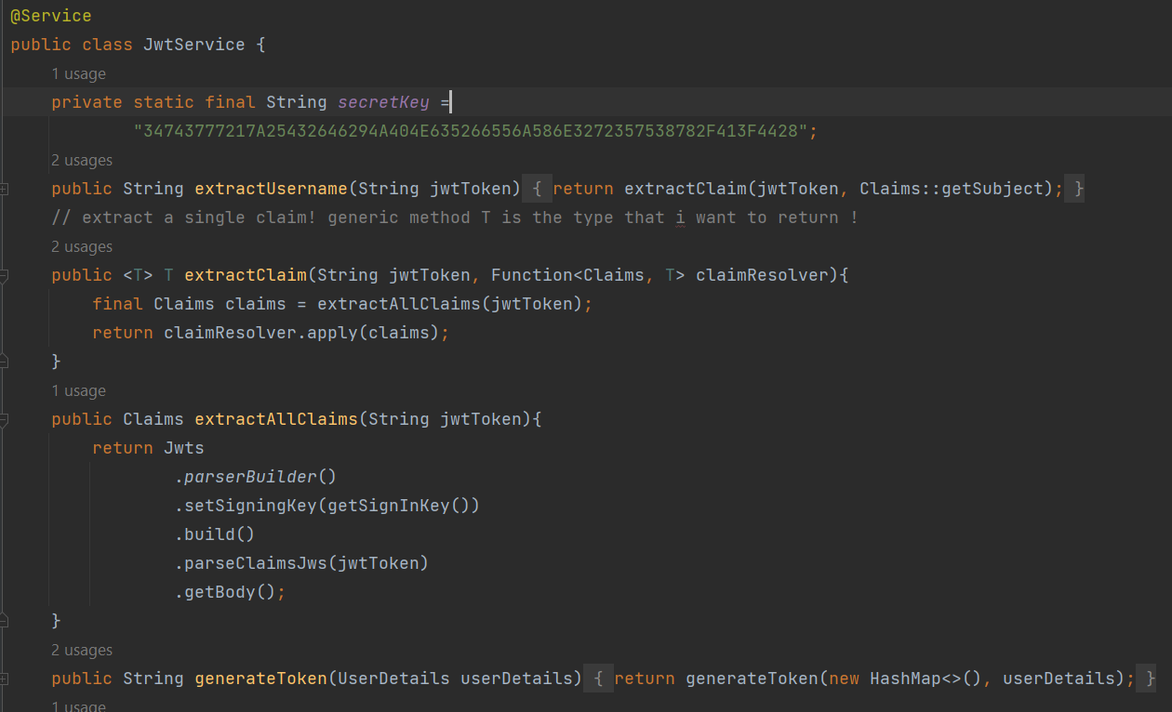

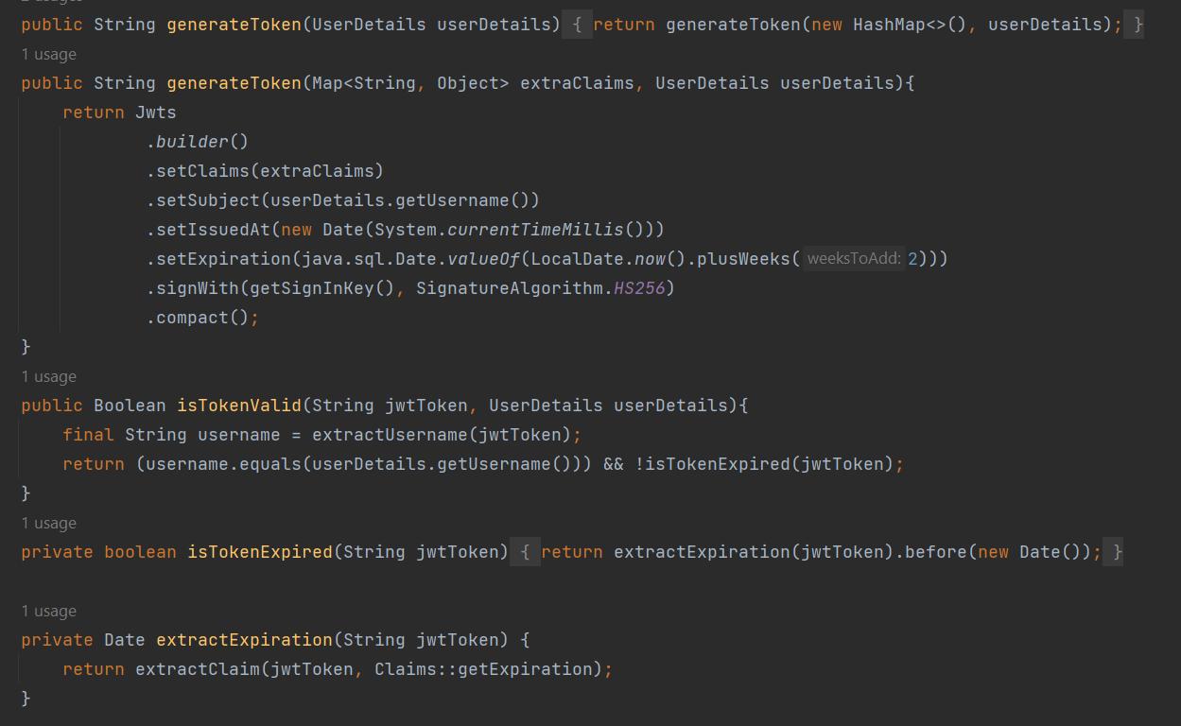

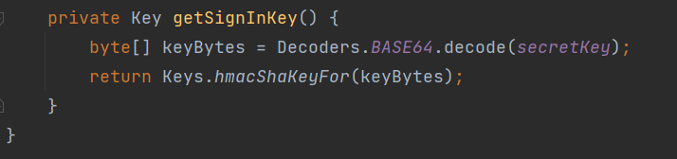

ApplicationConfig

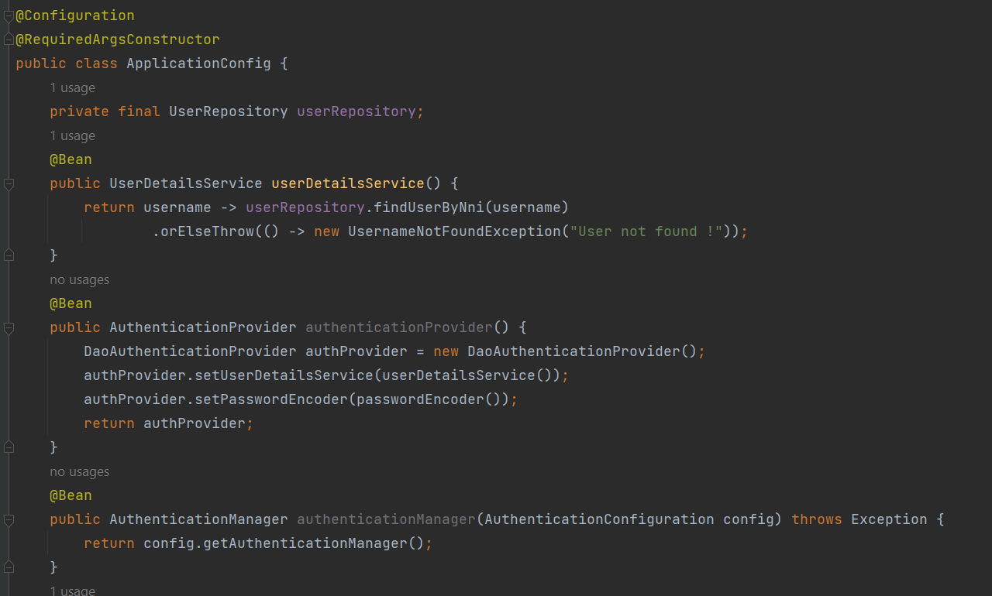

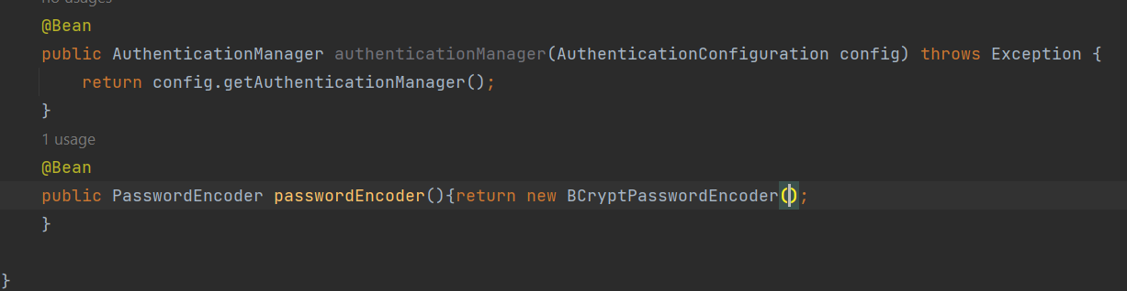

Auth package !

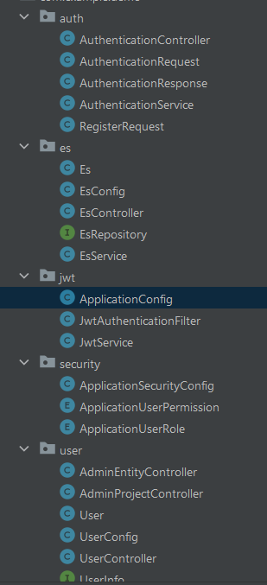

AuthenticationController !

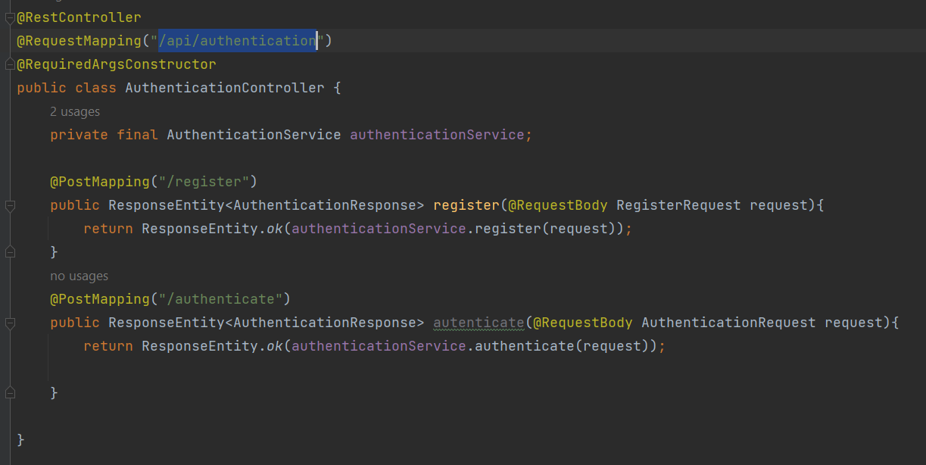

AuthenticationService !

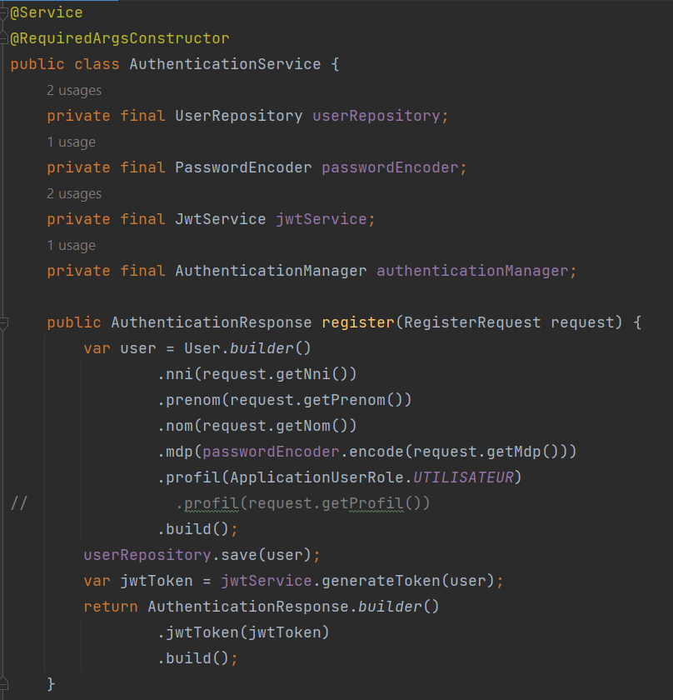

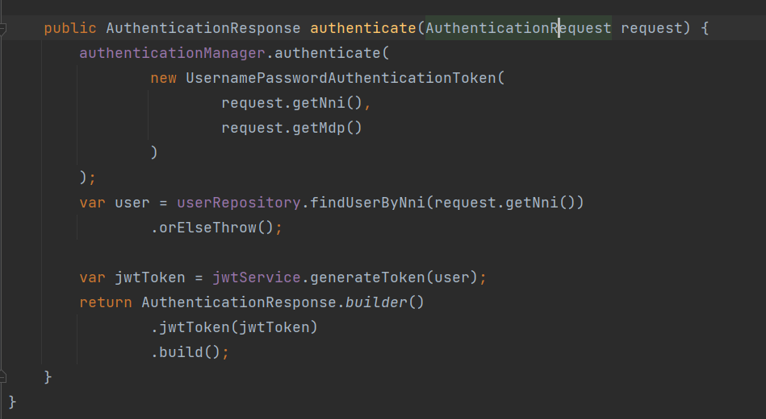

AuthenticationRequest !

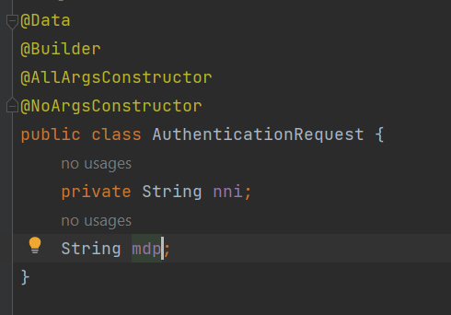

AuthenticationResponse !

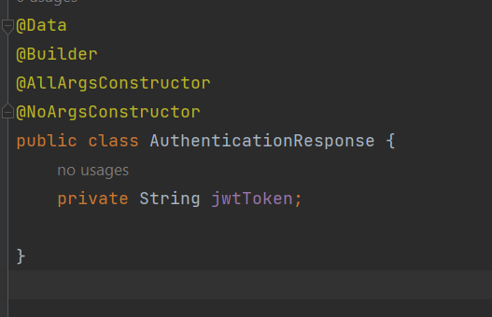

RegisterRequest !

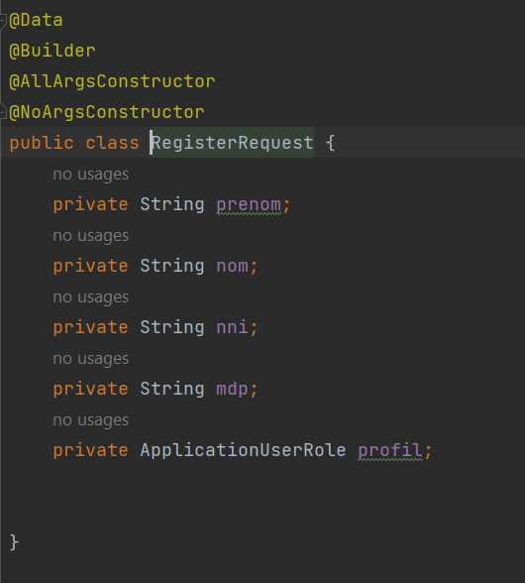

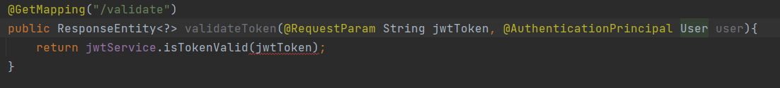

@AuthenticationPrincipal :

Allow us to get the authenticated user !